1. Create a new Controller named “Friend”.
2. Create a Model named “Friend” with following properties : FriendID,FriendName,Place
3. Create a Index (List of Friends) View and Method in Friend controller.  
     
   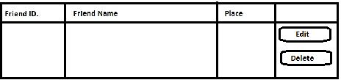
4. Make it FriendName as Error Message = Friend Name Empty Not Allowed.
5. Create a Insert new friend --> View and Method in Friend controller.  
     
   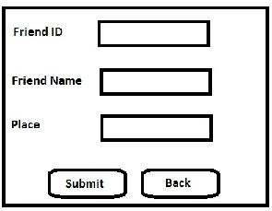
6. Insert new record with using Model in post.
7. Before Inserting check your Model means validate your model.
8. Create edit/Update View and Method in Controller.
9. Update record with using FormCollection technique.  
     
   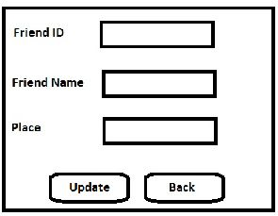
10. Create Delete view and Method for delete a friend.

Perform above all data CRUD (Create Retrieve Update Delete) activities in following ways:

1. Entity Framework